Machine Learning Strategy

COURSERA

Andrew NG

目录
Why ML Strategy 2
Orthogonalization 3
Single Number Evaluation Metric 3
Satisfice and Optimize Metrics 4
Train/Dev/Test Distribution 4
When should we change metrics? 5
Why human level performance? 6
Avoidable Bias 7
Understand human-level performance 7
Surpass human-level performance 7
Improve model performance 8

Why ML Strategy
- Help improve efficiency of the network

Orthogonalization
- Central Idea
One or one set of solutions that only change specific outcomes but not others.
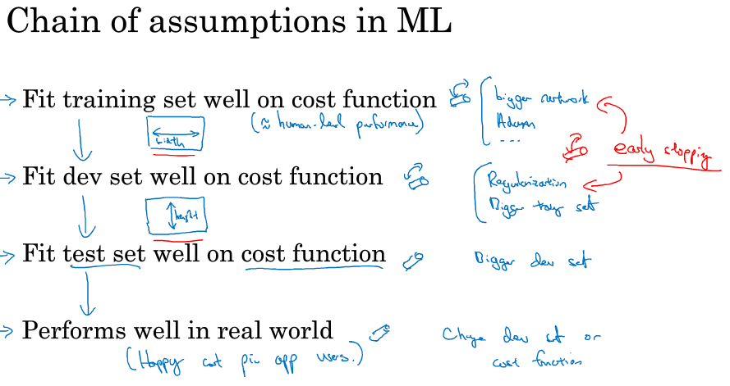
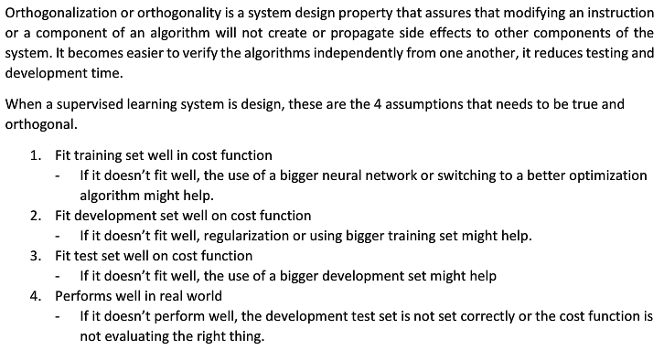

Single Number Evaluation Metric
- Central Ideal
Compute one single index from all to evaluate the system
- E.g.
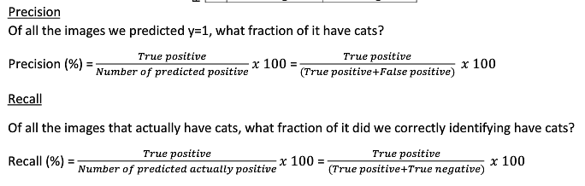
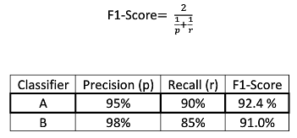

Satisfice and Optimize Metrics
- One main metric to optimize while others to satisfice
- Optimize means as high as possible, while satisfice only requires it to be above a certain level.

Train/Dev/Test Distribution
- Relations of three
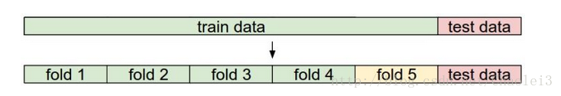
- Train set determines how fast we reach the optimal. It changes parameters.
- Test set, metrics and dev set define our target
- Test set is used only once for evaluation
- Dev set is used for determining best hyper-parameters. It does not participate training process
- Dev and test sets should be from same distribution and chosen randomly

- An example of cross-validation in Keras:

When should we change metrics?
- About loss
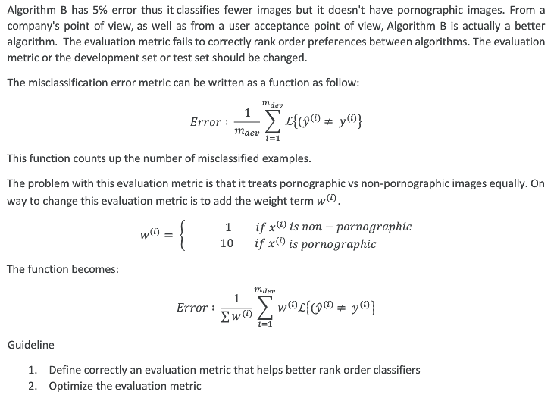
- About real performance
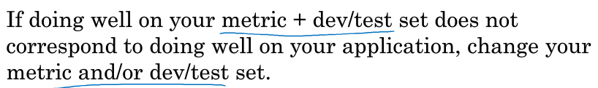

Why human level performance?
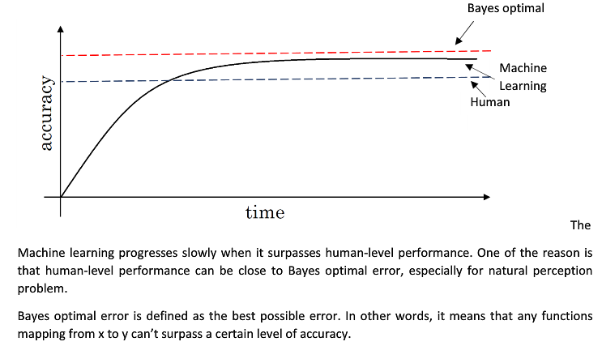
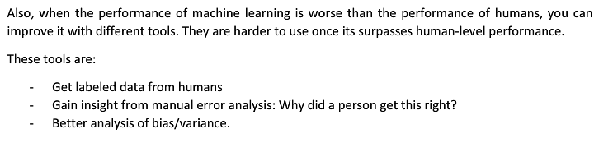

Avoidable Bias
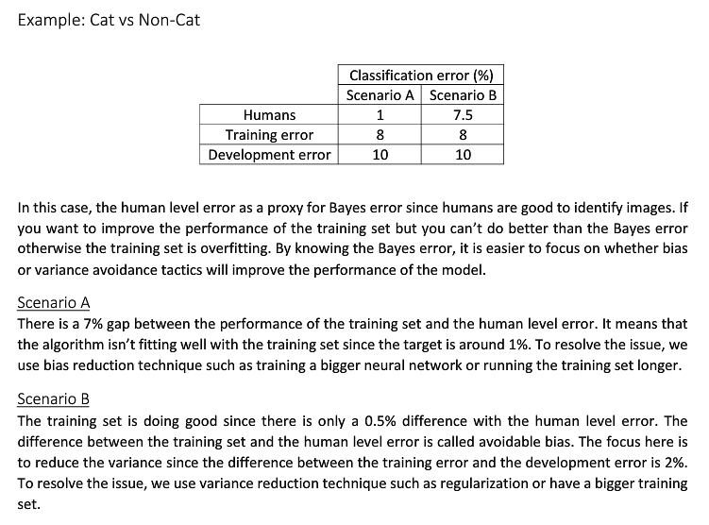

Understand human-level performance
- As a proxy for Beyas Optimal (best in theory)
You cannot surpass Beyas Optimal otherwise the network is overfitting.

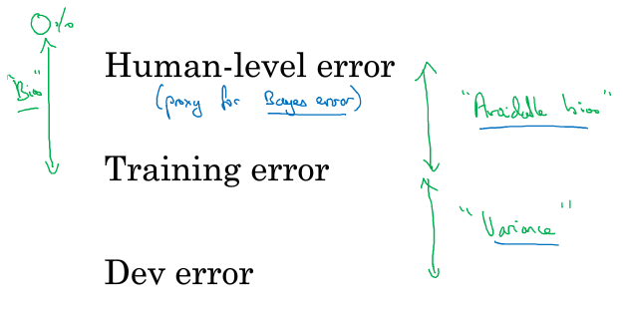

Surpass human-level performance
- Computer cannot compete humans in natural perception areas at present, although some specific tasks are not so.

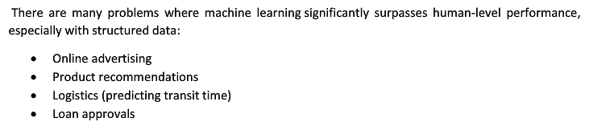

Improve model performance
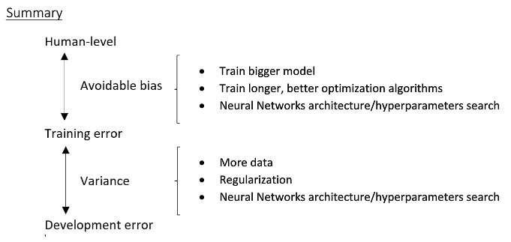

Carrying out error analyzing
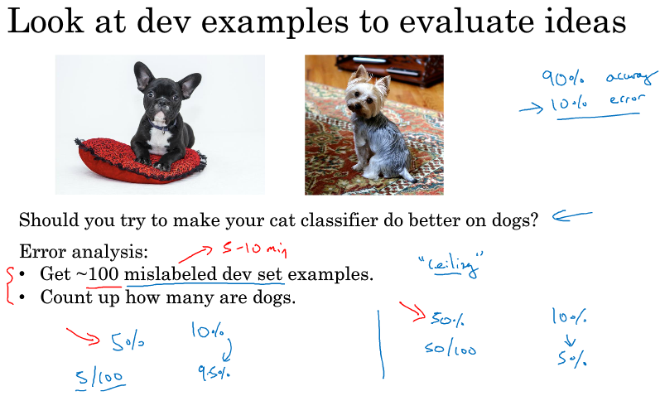
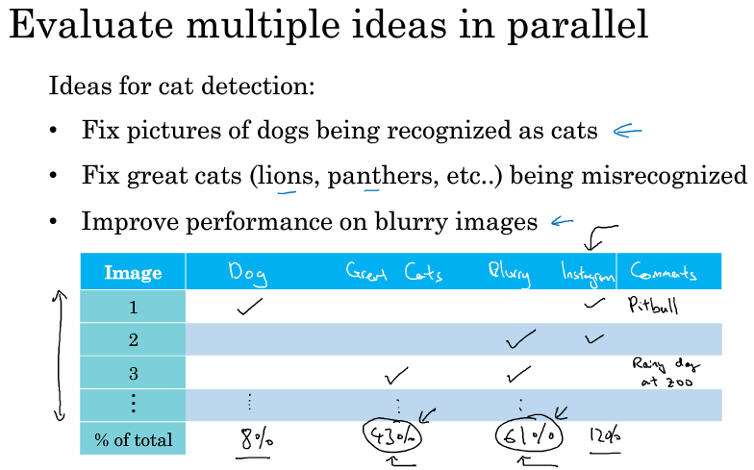

Cleaning up incorrectly labeled data
- For training set: DL algorithms are robust to random errors, but not systematic errors.
- For dev set: add label error to error analysis and decide
- Apply same process on train and dev set to ensure same distribution

Build your system and iterate
- Why?
An ideal system is fruit of iteration and optimization. Rome is not built overnight.
Set dev/test and metric -> build initial system -> analysis to prioritize next step

Train and test on different distribution
- Situation: 200,000 from web and 10,000 from app. You want to do well in app set.
Solution1: combine and shuffle, distribute randomly in three sets.
Solution2: 205,000 train, 2500 dev from app and 2500 test from app
Solution2 defines the target better!

Bias/variance in mismatching sets
- Training-dev set has same distribution with training set but not used for training
- Dev and test set have same distribution
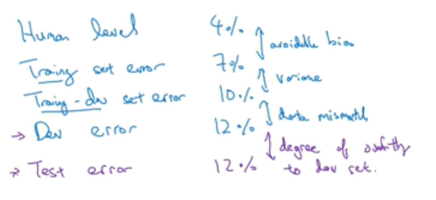

Addressing data mismatch
- Manual error analysis to understand the difference between training and dev sets.
- Make training data more similar / collect more data similar to dev/test data

Transfer learning
- Use a pre-trained model to fulfill another task
- Just replace the last layer and retrain the whole model (when dataset is large) or just fine tune the last layer params.
- Transfer learning makes sense when:
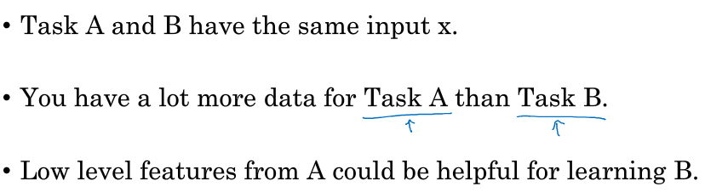

Multi-task learning
- One model predicting multiple objects at the same time.
- Multiple labels and outputs (so Softmax is useless)
- Works even when some labels are missing
- Multi-task learning makes sense when:
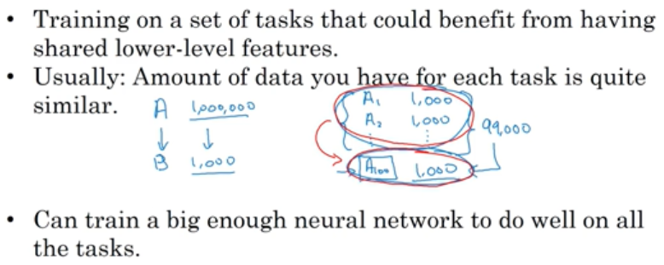

End-to-end deep learning
- Like a black box that requires no intervene but tons of preparation
- E.g.
Raw image -> face found -> zoom and crop -> identity recognition
- Pros
Let the data speak
Less hand-designing of components needed
- Cons
Need a lot of data
Exclude potentially useful components

